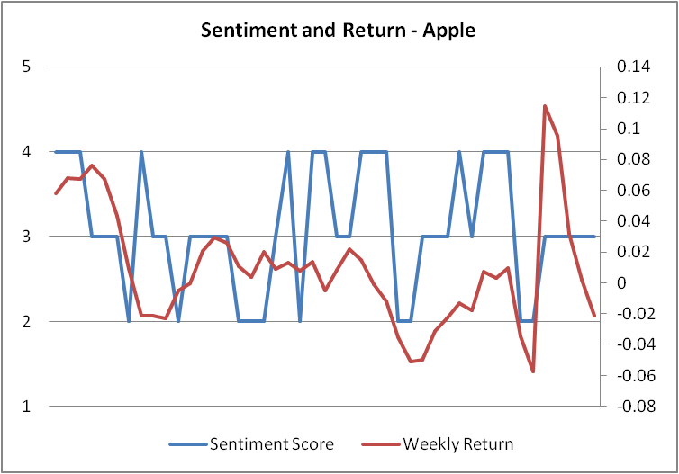

*Fig: Sentiment Score with return*

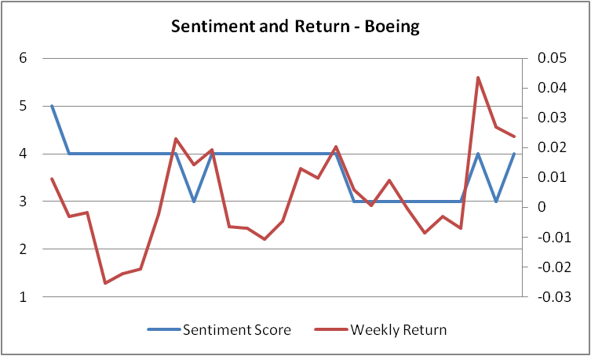

*Fig: Sentiment Score with return*

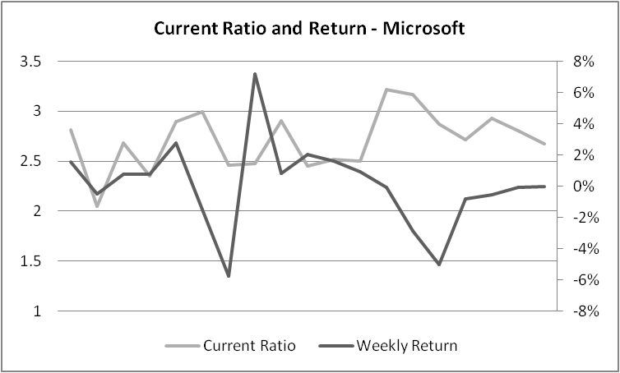

*Fig: Current Ratio with return*

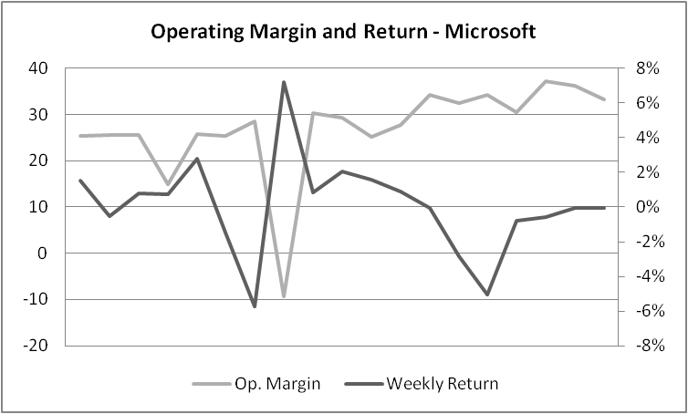

*Fig: Operating Margin with return*

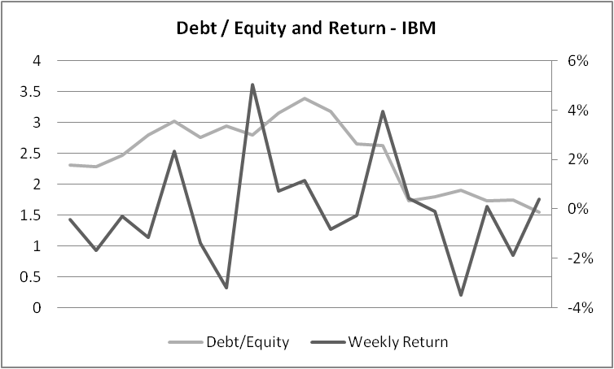

*Fig: Debt Equity Ratio with return*

*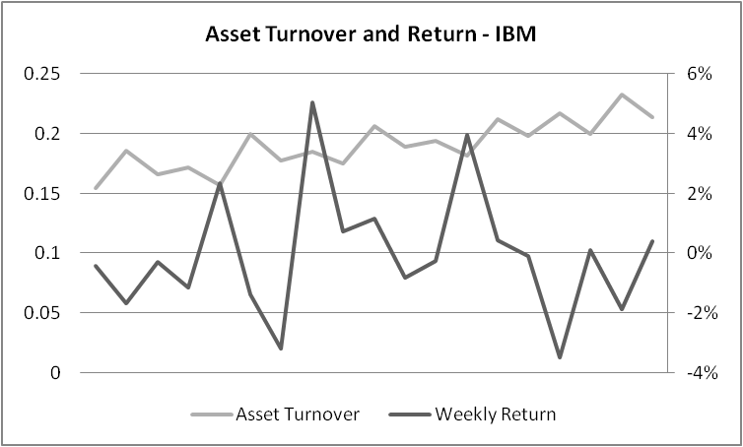*

*Fig: Operating Margin with return*